Sister Margaret Mary Littlehales CJ

April 5th 1907 to May 6th 2009

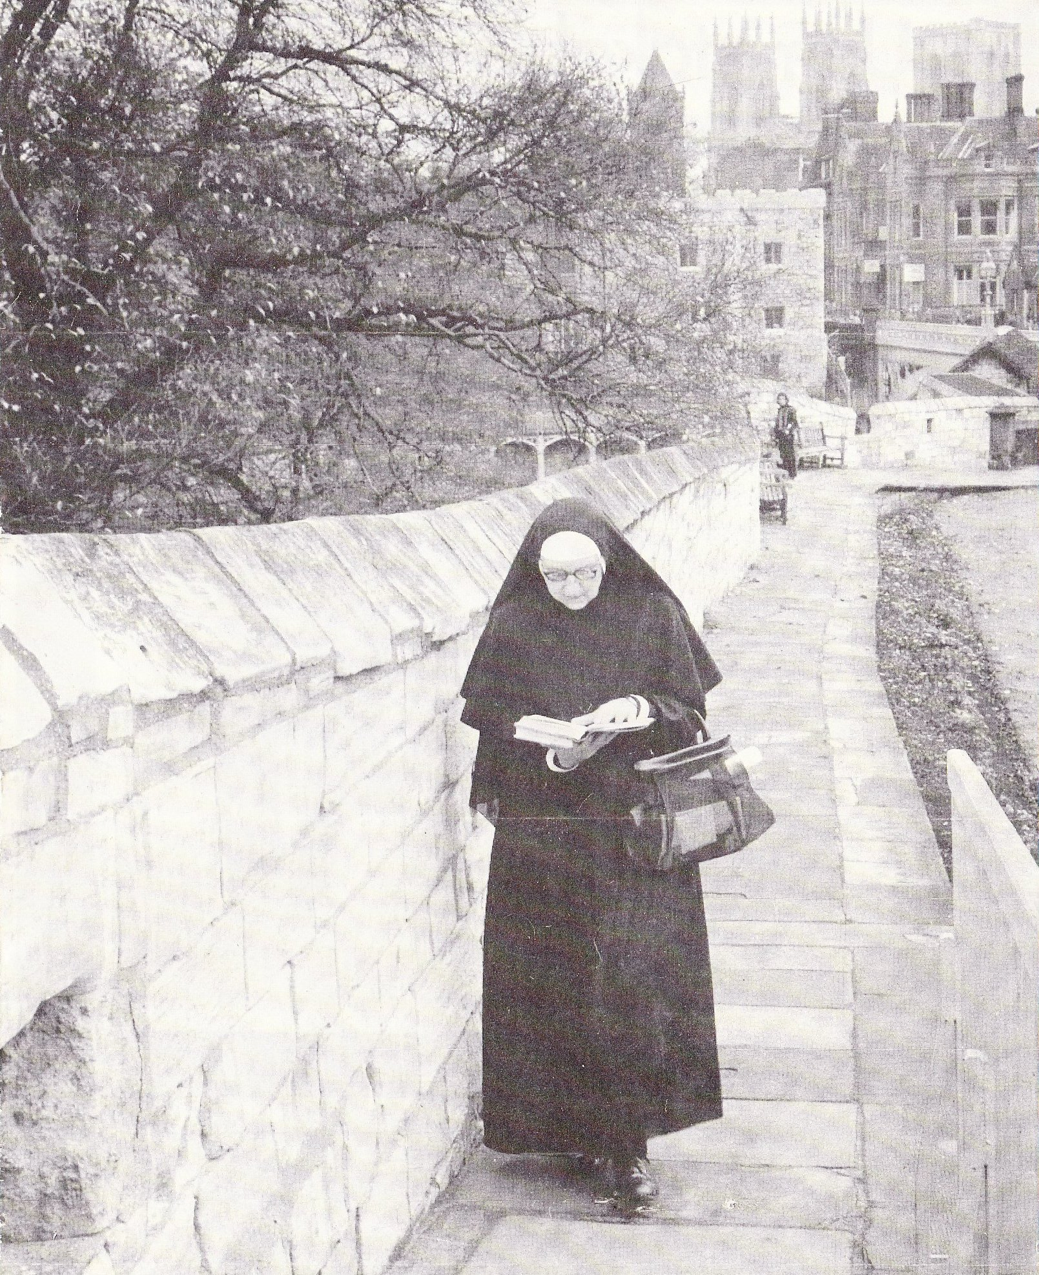
Consuelo Littlehales was bound by many family ties to Mary Ward’s Institute. Her family claimed collateral descent from Sir Thomas Gascoigne, founder of the Bar Convent, and her grandmother and two great aunts were at school there. Her mother, three aunts, she herself and a cousin Consuelo Ingram, were educated at Ascot, while her sister was a pupil in England’s Lane and Hampstead. All three of the last generation became members of the Institute as Sister Margaret Mary, Sister Magdalen and Sister Scholastica respectively.

The Consuelo who is the subject of this biography was born on 5th April 1907, the eldest daughter of Frederick Littlehales, a master mariner, and his wife Consuelo (née Hunter). Five children were born to them, and the family was comfortably off until Captain Littlehales was drowned at sea, leaving his brave widow to bring up the children on a much reduced income.

Consuelo was educated at St Mary’s Convent, Ascot. After leaving school she spent a year in Paris, perfecting her French before entering the Ascot noviceship in 1926 at the age of nineteen. She had already proved herself very intelligent, and after her religious training she was sent to Royal Holloway College where she took a General Degree and won a college prize. She then settled down as a member of the teaching staff in the various CJ schools, Cambridge, followed by Ascot, then York. She was increasingly successful in the classroom, where her English literature lessons were very popular. In 1940 she was sent to Bratton, where the Hampstead community and school had been evacuated. She had never lived in the country, never known an unconventional life, yet within a few weeks she was cycling round the Wiltshire lanes, hunting for orchids on the Downs, chasing butterflies, enjoying picnics, and convinced that the deprivations of evacuation were compensated by the joys of the countryside. There were the shadows, too, of an ever present war that drew children and nuns very close together.

After some four years of this unique existence she was back again in Ascot, active in the school, studying for a degree in Classics and teaching Greek and Latin. In 1954 she was in York again, now a mature religious and an influential member of the community. The next twenty-six years were the busiest and most productive of her busy life. She taught English literature with such enthusiasm and success that many generations of pupils ascribed their love of literature to her lessons. She became a fervent member of the charismatic movement, acted as the convent choir mistress and studied for a degree in German. She wrote a book on Mary Ward for children and innumerable articles for the press; she laid the foundation of the “antique library” by collecting the old books from many parts of the house, had the shabbiest rebound, and encouraged Dr. Norah Gurney, Archivist at the Borthwick Institute, to sort out and catalogue the convent archives. She formed close friendships with the members of the Georgian Society, particularly Dr Eric Gee, who advised on the reinstatement of the 18th century windows and other Georgian features. For good measure she interested herself in the planting of trees and shrubs in the garden, and in the house voiced her opinion on the colour of the paint-work and the planning of new bathrooms. She became such an integrated member of the York community that it was a surprise to all when she asked to be transferred to Cambridge. She moved there in 1980 and spent five years in comparative retirement, writing and doing some pastoral work.

In 1985 a small foundation was made in Norwich, to help the over-burdened priest whose parish stretched to the coast. The challenge stirred Sister Margaret Mary’s apostolic zeal and love of adventure. She became a founder member of the community, took to parish life with great enthusiasm, and was once more fully active, preparing candidates for the Sacraments, giving courses on Scripture, singing in the parish choir and making a host of new friends. For years it seemed as if her energy was inexhaustible, but old age gradually sapped her strength and in 1999 infirmity necessitated her admittance to St. Joseph’s. It was her third and last period of residence in York. For a time she seemed as active as ever, supporting the charismatic movement, winning prizes by the solution of high-brow puzzles, making new friends and spending her holidays with old ones. So the years crept by, slowly forcing her into complete retirement as she became less and less aware of the surroundings that had so quickened her interest half a century earlier.

Such are the facts of Sister Margaret Mary’s life. Her achievements for the most part have been mentioned as they occurred, with the exception of her authorship, which merits special attention. In addition to innumerable articles and short pieces, she wrote three biographies of Mary Ward. The first, The Wedge of Gold, published in 1955, was written for children and is a lively and vivid account, but it is marred by over-romanticism and by the author’s love of unusual words. The second, Mary Ward. A Woman for all Seasons, came out in 1974 and is a valuable pamphlet written in a much more disciplined style. It found a ready market. Her most notable work, the full-length biography entitled Mary Ward, Pilgrim and Mystic, was begun in 1975 and took twenty-three years to complete. Published in 1998 it was an instant best-seller, fulfilling a need for a well researched, middle-brow life of this pioneer among women. It testifies too to Sister Margaret Mary’s humility and perseverance: she had worked on the original documents in the Munich/Nymphenburg archives, but she submitted each chapter to experts, accepted their criticisms and corrections, and re-wrote every section several times. She had a struggle to find a publisher, but did not lose heart; eventually she persuaded the stalwart Catholic firm, Burns Oates, to accept the script, and she saw it through the press in 1998. Its triumph led to many congratulatory letters that gave her great pleasure.

It is difficult to describe a character as complex as hers. An original thinker who lived life to the full, she had a keen appreciation of music, literature, natural beauty, art, and linguistics, and was eager to explore their avenues. She was avid to read new books, to experience continental travel and foreign food, to make new acquaintances and to hear the latest theories on everything from the cure of disease to the origin of the universe. Strangely, she was credulous to the point of naivety, accepting with enthusiasm wild newspaper statements on history and science. To the despair of her sceptical friends, she was constantly convinced that she had won £50,000 or an expensive car, to be delivered on receipt of £10 or so. Many a trickster must have literally “laughed all the way to the bank” as he made his way there with the money in his pocket.

There was generosity too in her make-up. Her many friendships involved giving as well as taking, and she was always faithful to a friend – even to one who murdered his wife! Professionally she never begrudged time and energy spent on responsive pupils. In York a group of children asked her to teach them German; the subject was not on the curriculum, but she agreed to hold a German class every Saturday morning, subject to regular attendance. In community she was a good and interesting companion, an outstanding personality that clings to the memory. But it is her 83 years of service to God in Mary Ward’s Institute that deserve remembrance. In September 2006 she celebrated the 80th anniversary of her entry into religious life, a Jubilee far beyond the titles given to such anniversaries.

She came of a family noted for its longevity and she was no exception to the family rule. She kept her 100th birthday in April 2007 - quietly, but with Mass celebrated in St Joseph’s chapel, a personal card from the Queen, and 100 other cards from family, community and friends. She lived on for two years more, to see the new extension to St Joseph’s almost completed. She died in one of the new rooms there on May 6th 2009 at the age of 102, and was buried in the Bar Convent cemetery, where her sister Scholastica and her cousin Magdalen had preceded her.
Written by the late Sr Gregory Kirkus CJ
Final editing by Sr Christina CJ

